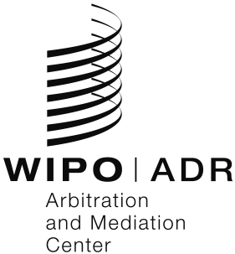

Request for WIPO Mediation

1. Parties

Please provide the following contact information:
Initiating Party in the dispute |  |  |  | Responding Party in the dispute
Name | : |  |  | Name | :
Country of domicile | : |  |  | Country of domicile | :
Tel | : |  |  | Tel | :
Email | : |  |  | Email | :
Address | : |  |  | Address | :
Represented by | : |  |  | Represented by | :
Tel | : |  |  | Tel | :
Email | : |  |  | Email | :
Address | : |  |  | Address | :

2. Dispute

Please provide a brief description of the dispute:

3. Time period for mediation

The following period will be set aside for mediation, as may be extended upon agreement:
☐ | 30 days
☐ | 60 days
☐ | 90 days

4. Submission to WIPO Mediation

Initiating Party in the dispute |  |  |  | Responding Party in the dispute
- The initiating Party in the dispute agrees to submit the above-described dispute to mediation in accordance with the WIPO Mediation Rules.  Please sign this form and submit it to arbiter.mail@wipo.int, the Responding Party and IPOS. |  |  |  | - The responding Party in the dispute agrees to submit the above-described dispute to mediation in accordance with the WIPO Mediation Rules.  Please sign this form and submit it to arbiter.mail@wipo.int, the Initiating Party and IPOS.
Signature | : |  |  | Signature | :
Place and Date | : |  |  | Place and Date | :

Note on funding:
Effective April 1, 2022, parties to IPOS proceedings can benefit from the Revised Enhanced Mediation Promotion Scheme (REMPS), which will fund their mediation costs up to SGD 10,000 or up to SGD 14,000 where foreign intellectual property rights are added to the subject-matter of mediation.
Further information on the conditions for REMPS funding can be found at https://www.ipos.gov.sg/manage-ip/develop-capabilities.

